|  |  |  |  |  |  |
| --- | --- | --- | --- | --- | --- |
| Date | 29-Nov-22 | | | Tester Name | Shahabuddin Syed |
| Environment | Select Environment | | | Login used |  |
| Operating System | Windows | Version: | Update: | | |
| Software Used | Edge | Version: | Update: | | |
| Select Software | Version: | Update: | | |
| Release version | 22.4.1 | | | | |
| Title |  | | | | |
| Test Type | Regression | | | | |
| Test Scenario | Change an Employee’s Department Code | | | | |
|  |  | | | | |
| Expected Results |  | | | | |
| Pass/Fail | Pass | | | JIRA# | N/A |

Describe your steps with screenshots:

In PENFAX5 Look for a member with Active status.

Keep track of their employer, current department code, Name and EEID

SID# 285691

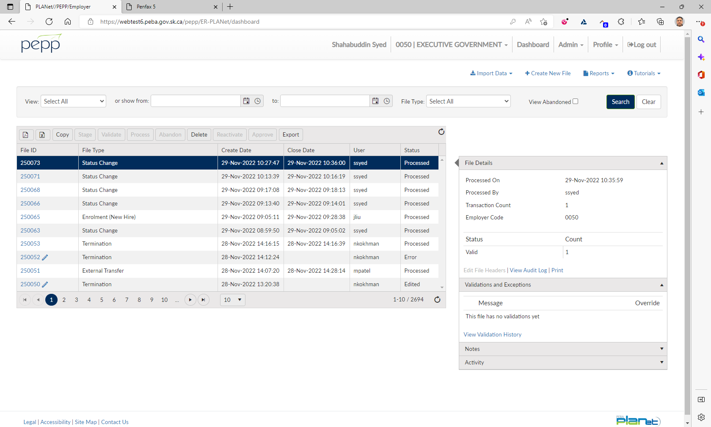

Log into DCT

Select the employer from step 1

Click on Create New File

Select Status Change from the dropdown

Click Create

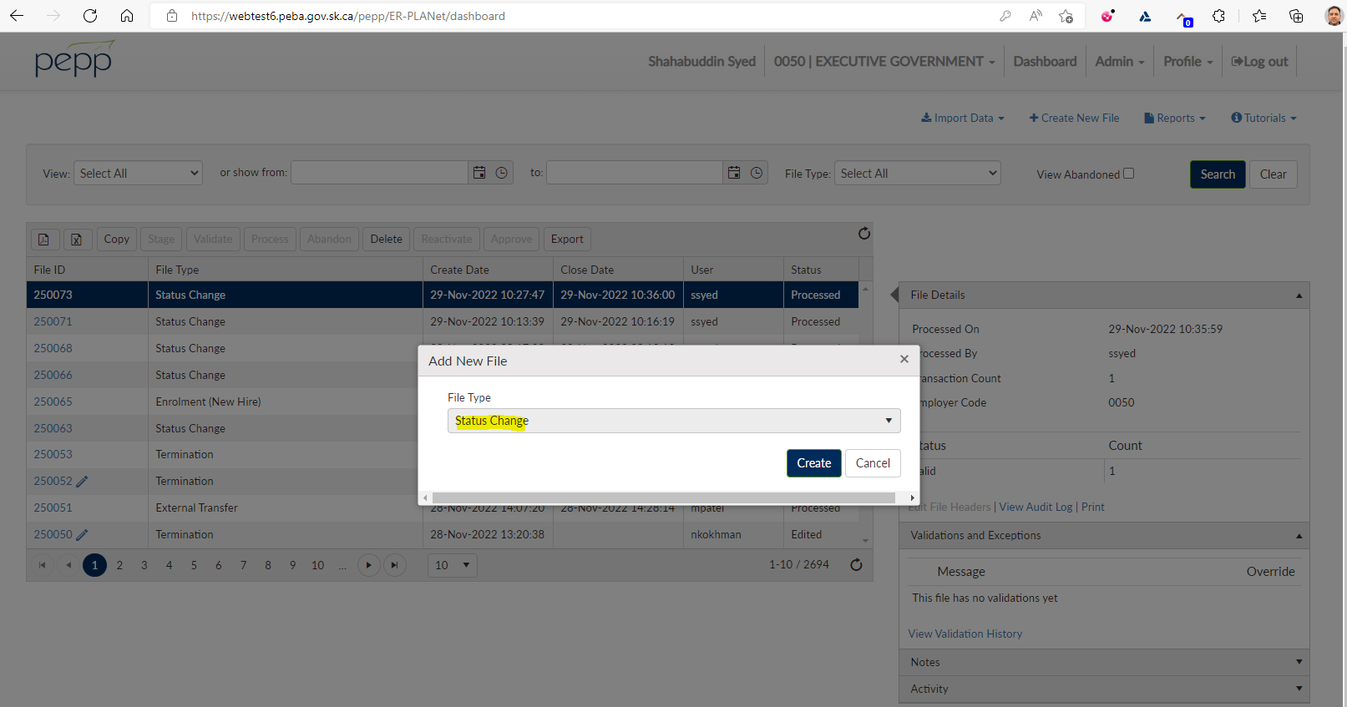

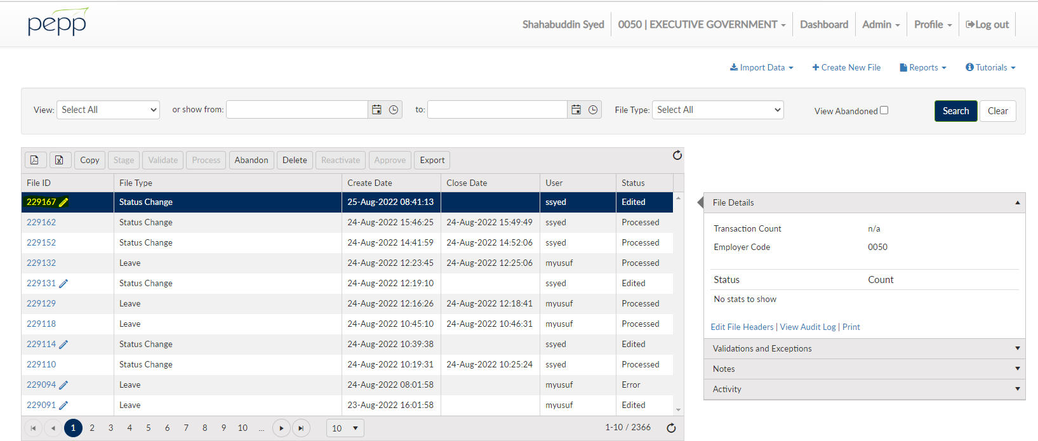

Need to enter the Department 1 field

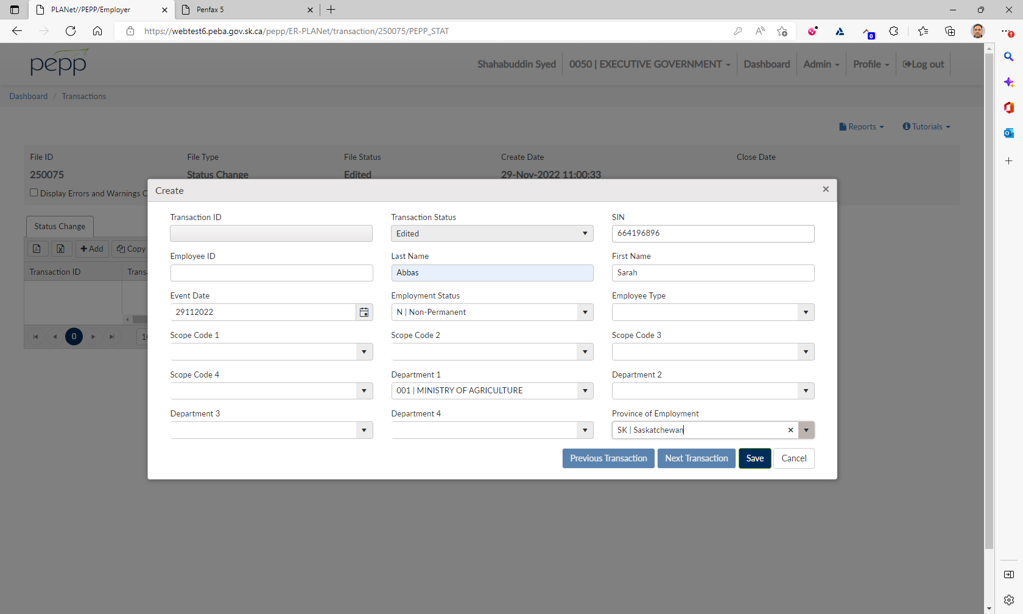

Need to Validate

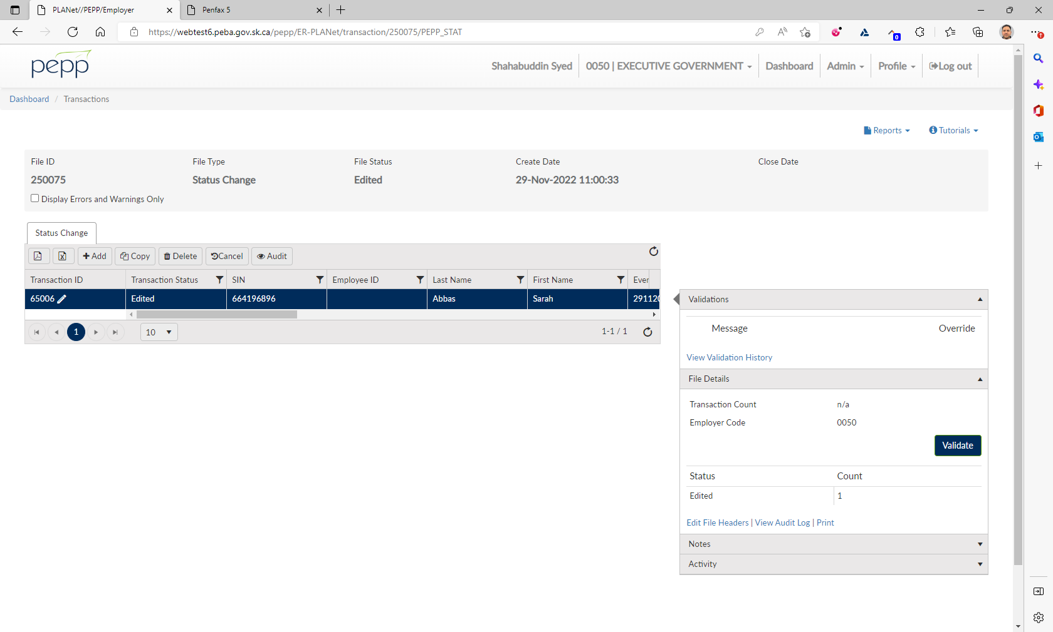

Click on Process

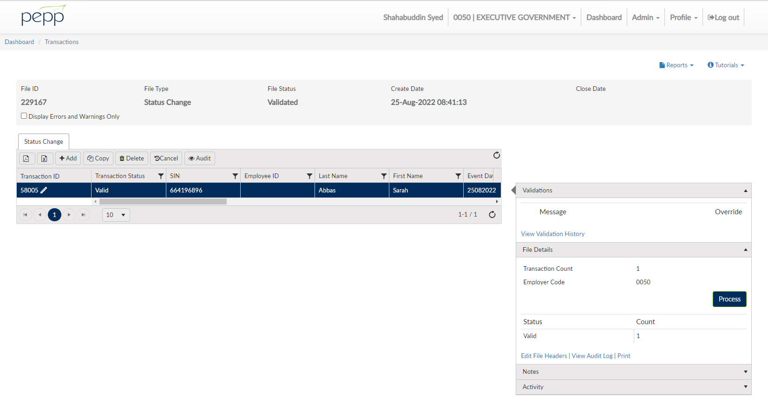

File Status should be Processed

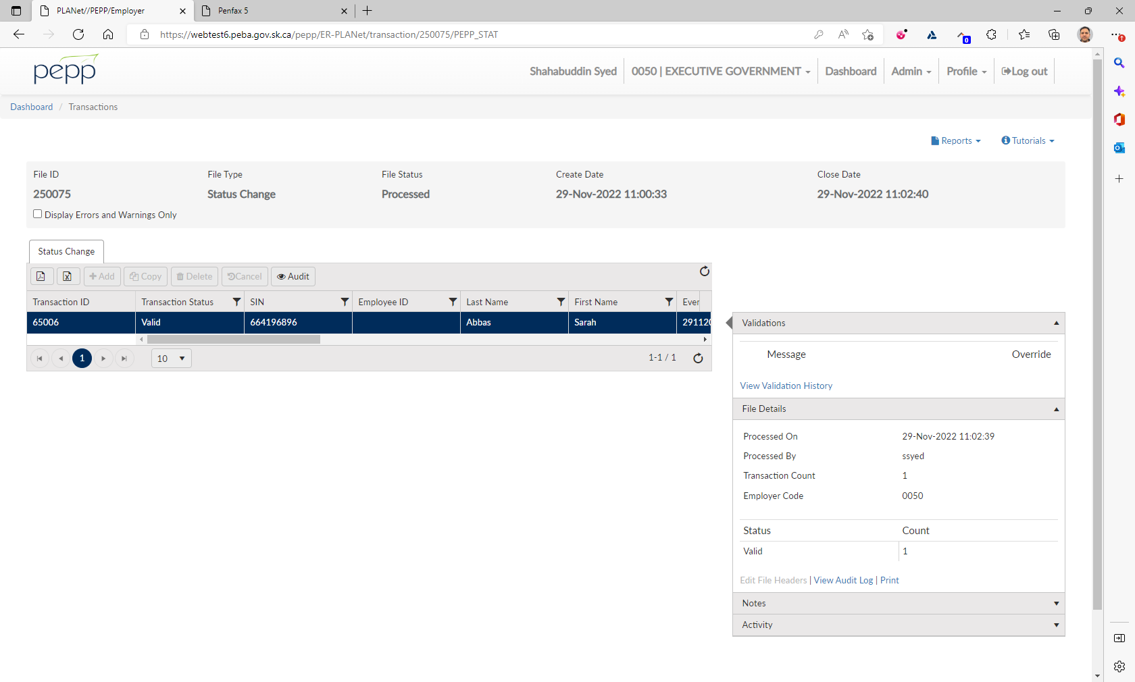

Need to move to Penfax

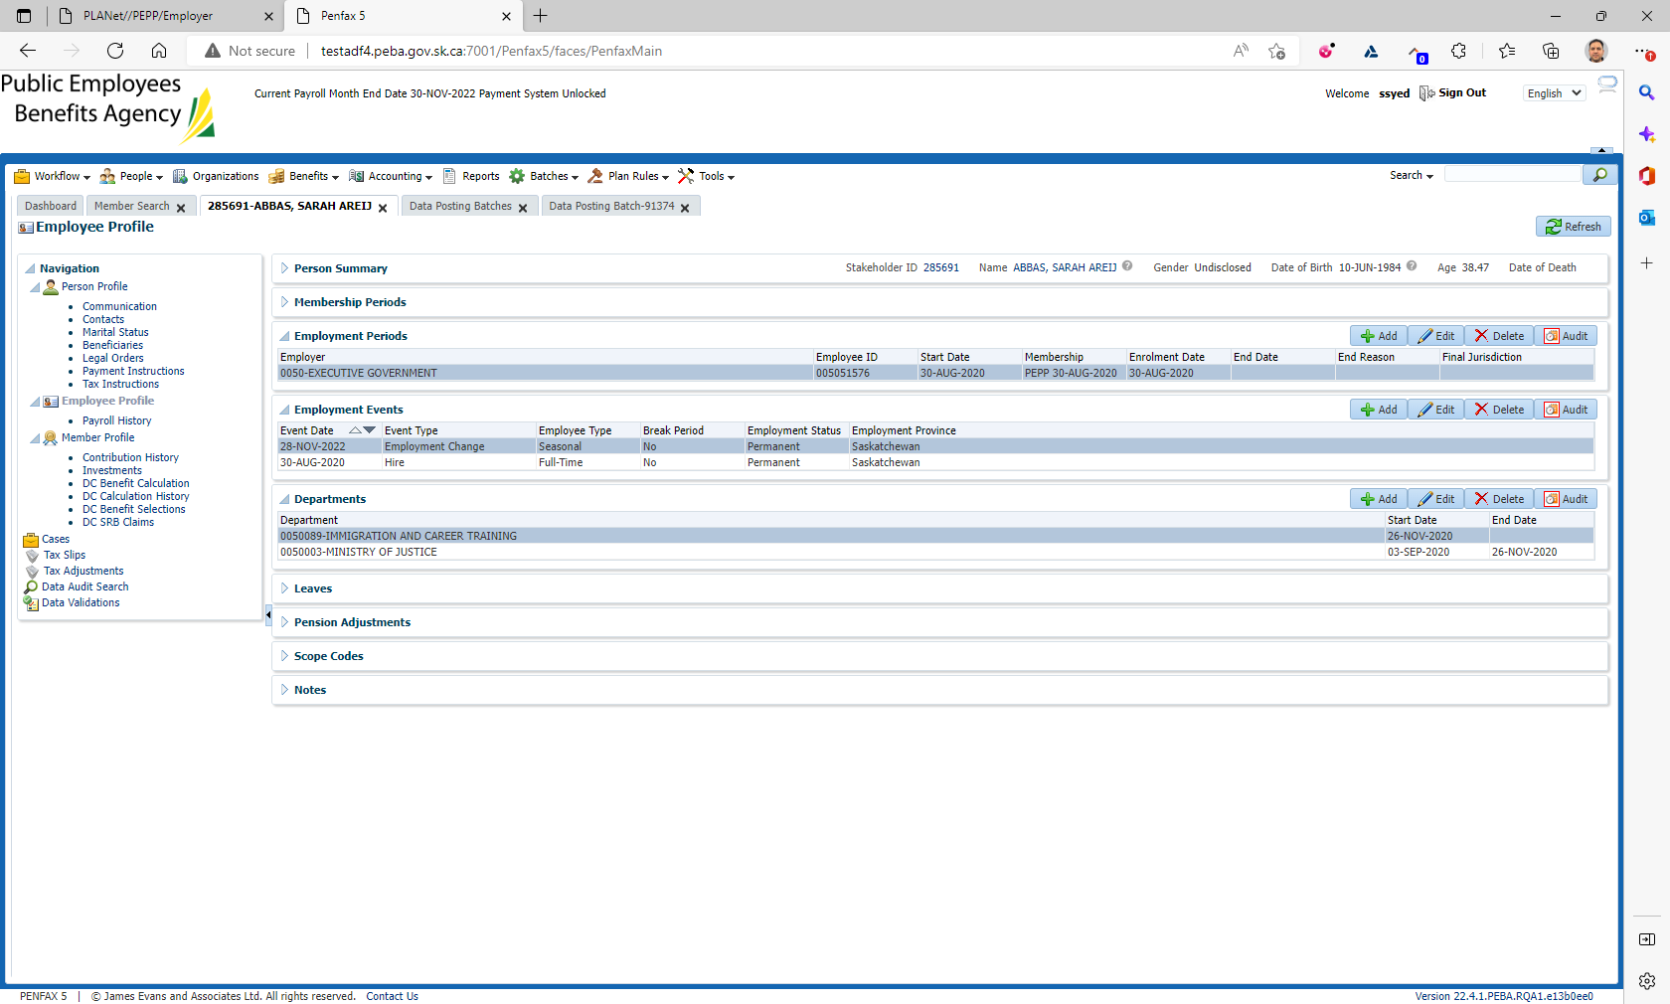

Need to go to Batches 🡪 Data Posting Batch

Status shows as Pending

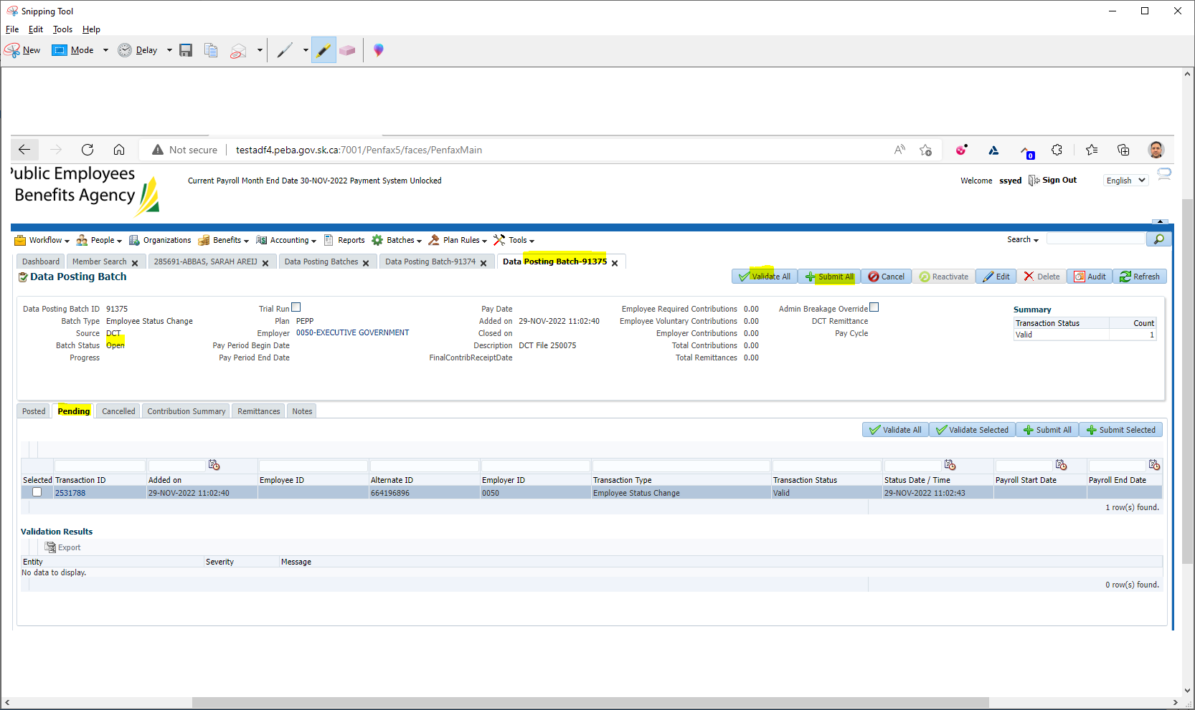

Click on Validate All and Submit All

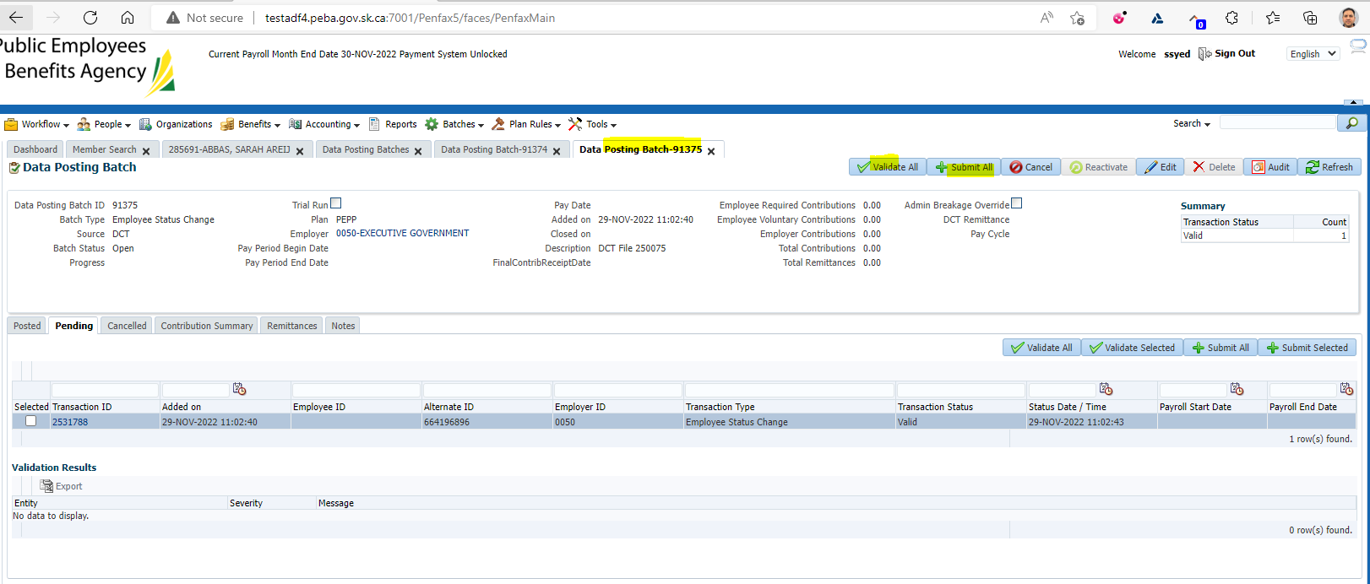

Refresh to check if the status changes from Pending to Posted

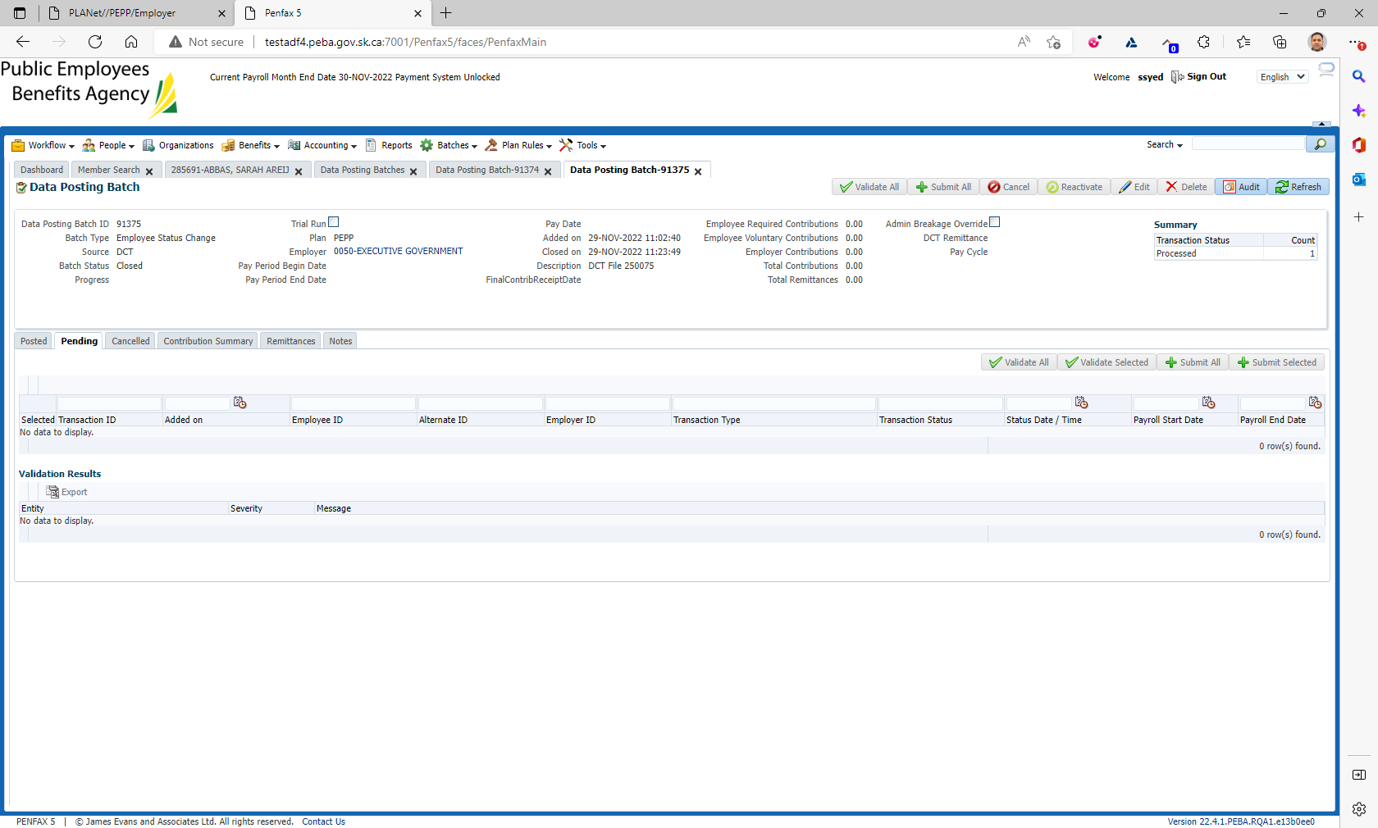

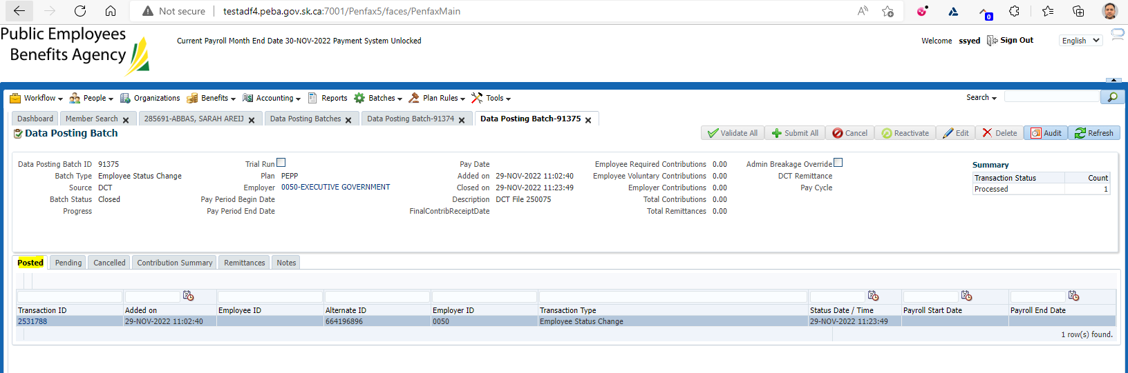

Verify if the Departments are updated with the end date on the previous department

